Introduction to Object-Oriented Programming

# Why object-oriented programming?

Object-oriented programming has a few benefits over procedural programming, which is the programming style you most likely first learned. As you'll see in this lesson:

* Object-oriented programming allows you to create large, modular programs that can easily expand over time.
* Object-oriented programs hide the implementation from the end user.

Consider Python packages like [Scikit-learn](https://github.com/scikit-learn/scikit-learn), [pandas](https://pandas.pydata.org/), and [NumPy](http://www.numpy.org/). These are all Python packages built with object-oriented programming. Scikit-learn, for example, is a relatively large and complex package built with object-oriented programming. This package has expanded over the years with new functionality and new algorithms.

When you train a machine learning algorithm with Scikit-learn, you don't have to know anything about how the algorithms work or how they were coded. You can focus directly on the modeling.

Here's an example taken from the [Scikit-learn website](http://scikit-learn.org/stable/modules/svm.html):

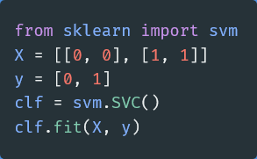

How does Scikit-learn train the SVM model? You don't need to know because the implementation is hidden with object-oriented programming. If the implementation changes, you (as a user of Scikit-learn) might not ever find out. Whether or not you *should* understand how SVM works is a different question.

In this lesson, you'll practice the fundamentals of object-oriented programming. By the end of the lesson, you'll have built a Python package using object-oriented programming.

# Procedural versus object-oriented programming

Objects are defined by characteristics and actions

Here is a reminder of what is a characteristic and what is an action.

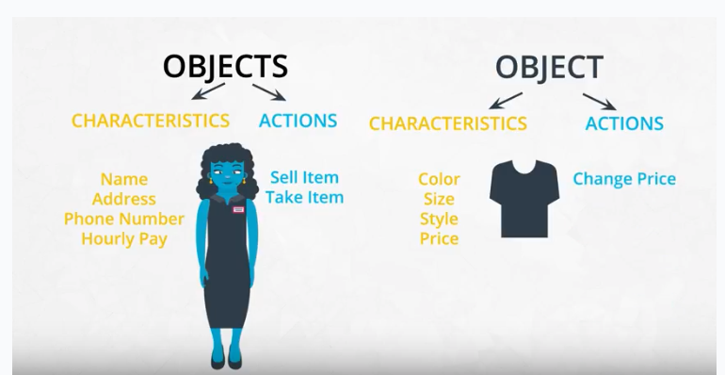

## Characteristics and actions in English grammar

You can also think about characteristics and actions is in terms of English grammar. A characteristic corresponds to a noun and an action corresponds to a verb.

Let's pick something from the real world: a dog. Some characteristics of the dog include the dog's weight, color, breed, and height. These are all nouns. Some actions a dog can take include to bark, to run, to bite, and to eat. These are all verbs.

# Class, object, method, and attribute

## Object-oriented programming (OOP) vocabulary

* Class: A blueprint consisting of methods and attributes.
* Object: An instance of a class. It can help to think of objects as something in the real world like a yellow pencil, a small dog, or a blue shirt. However, as you'll see later in the lesson, objects can be more abstract.
* Attribute: A descriptor or characteristic. Examples would be color, length, size, etc. These attributes can take on specific values like blue, 3 inches, large, etc.
* Method: An action that a class or object could take.
* OOP: A commonly used abbreviation for object-oriented programming.
* Encapsulation: One of the fundamental ideas behind object-oriented programming is called encapsulation: you can combine functions and data all into a single entity. In object-oriented programming, this single entity is called a class. Encapsulation allows you to hide implementation details, much like how the scikit-learn package hides the implementation of machine learning algorithms.

In English, you might hear an attribute described as a property, description, feature, quality, trait, or characteristic. All of these are saying the same thing.

Here is a reminder of how a class, an object, attributes, and methods relate to each other.

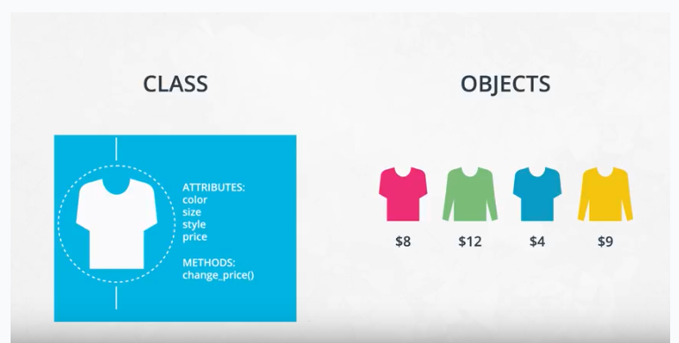

# Object-oriented programming syntax

## Function versus method

In the video above, at 1:44, the dialogue mistakenly calls ***init*** a function rather than a method. Why is ***init*** not a function?

A function and a method look very similar. They both use the def keyword. They also have inputs and return outputs. The difference is that a method is inside of a class whereas a function is outside of a class.

## What is self?

If you instantiate two objects, how does Python differentiate between these two objects?

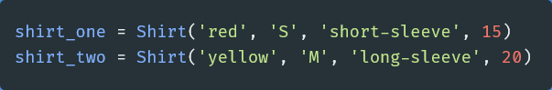

That's where self comes into play. If you call the change_price method on shirt_one, how does Python know to change the price of shirt_one and not of shirt_two?

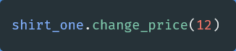

Behind the scenes, Python is calling the change_price method:

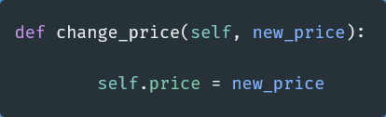

Self tells Python where to look in the computer's memory for the shirt_one object. Then, Python changes the price of the shirt_one object. When you call the change_price method, shirt_one.change_price(12), self is implicitly passed in.

The word self is just a convention. You could actually use any other name as long as you are consistent, but you should use self to avoid confusing people.

## Set and get methods

The last part of the video mentioned that accessing attributes in Python can be somewhat different than in other programming languages like Java and C++. This section goes into further detail.

The Shirt class has a method to change the price of the shirt: shirt_one.change_price(20). In Python, you can also change the values of an attribute with the following syntax:

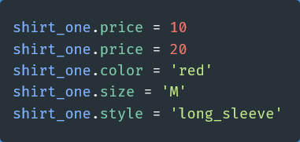

This code accesses and changes the price, color, size, and style attributes directly. Accessing attributes directly would be frowned upon in many other languages, **but not in Python**. Instead, the general object-oriented programming convention is to use methods to access attributes or change attribute values. These methods are called set and get methods or setter and getter methods.

A get method is for obtaining an attribute value. A set method is for changing an attribute value. If you were writing a Shirt class, you could use the following code:

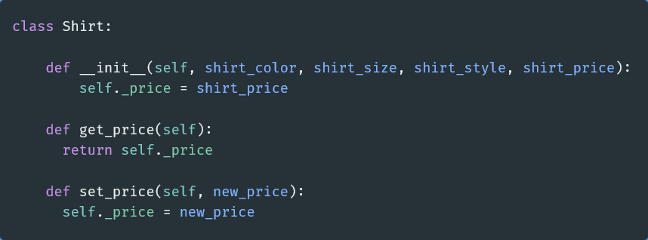

Instantiating and using an object might look like the following code:

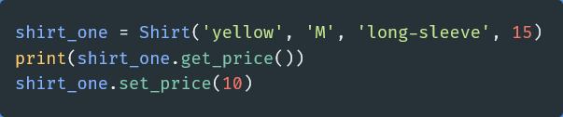

In the class definition, the underscore in front of price is a somewhat controversial Python convention. In other languages like C++ or Java, price could be explicitly labeled as a private variable. This would prohibit an object from accessing the price attribute directly like shirt_one._price = 15. Unlike other languages, Python does not distinguish between private and public variables. Therefore, there is some controversy about using the underscore convention as well as get and set methods in Python. Why use get and set methods in Python when Python wasn't designed to use them?

At the same time, you'll find that some Python programmers develop object-oriented programs using get and set methods anyway. Following the Python convention, the underscore in front of price is to let a programmer know that price should only be accessed with get and set methods rather than accessing price directly with shirt_one._price. However, a programmer could still access _price directly because there is nothing in the Python language to prevent the direct access.

To reiterate, a programmer could technically still do something like shirt_one._price = 10, and the code would work. But accessing price directly, in this case, would not be following the intent of how the Shirt class was designed.

One of the benefits of set and get methods is that, as previously mentioned in the course, you can hide the implementation from your user. Perhaps, originally, a variable was coded as a list and later became a dictionary. With set and get methods, you could easily change how that variable gets accessed. Without set and get methods, you'd have to go to every place in the code that accessed the variable directly and change the code.

## Attributes

There are some drawbacks to accessing attributes directly versus writing a method for accessing attributes.

In terms of object-oriented programming, the rules in Python are a bit looser than in other programming languages. As previously mentioned, in some languages, like C++, you can explicitly state whether or not an object should be allowed to change or access an attribute's values directly. Python does not have this option.

Why might it be better to change a value with a method instead of directly? Changing values via a method gives you more flexibility in the long-term. What if the units of measurement change, like if the store was originally meant to work in US dollars and now has to handle Euros? Here's an example:

### Example: Dollars versus Euros

If you've changed attribute values directly, you'll have to go through your code and find all the places where US dollars were used, such as in the following:

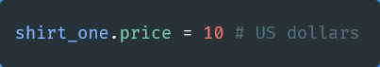

Then, you'll have to manually change them to Euros.

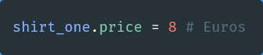

If you had used a method, then you would only have to change the method to convert from dollars to Euros.

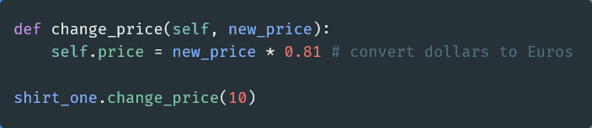

For the purposes of this introduction to object-oriented programming, you don't need to worry about updating attributes directly versus with a method; however, if you decide to further your study of object-oriented programming, especially in another language such as C++ or Java, you'll have to take this into consideration.

## Modularized code

Thus far in the lesson, all of the code has been in Jupyter Notebooks. For example, in the previous exercise, a code cell loaded the Shirt class, which gave you access to the shirt class throughout the rest of the notebook.

If you were developing a software program, you would want to modularize this code. You would put the Shirt class into its own Python script, which you might call shirt.py. In another Python script, you would import the Shirt class with a line like from shirt import Shirt.

For now, as you get used to OOP syntax, you'll be completing exercises in Jupyter Notebooks. Midway through the lesson, you'll modularize object-oriented code into separate files.

## Commenting object-oriented code

Did you notice anything special about the answer key in the previous exercise? The Pants class and the SalesPerson class contained docstrings! A docstring is a type of comment that describes how a Python module, function, class, or method works. Docstrings are not unique to object-oriented programming.

For this section of the course, you just need to remember to use docstrings and to comment your code. It will help you understand and maintain your code and even make you a better job candidate.

From this point on, please always comment your code. Use both inline comments and document-level comments as appropriate.

### Docstrings and object-oriented code

The following example shows a class with docstrings. Here are a few things to keep in mind:

* Make sure to indent your docstrings correctly or the code will not run. A docstring should be indented one indentation underneath the class or method being described.
* You don't have to define self in your method docstrings. It's understood that any method will have self as the first method input.

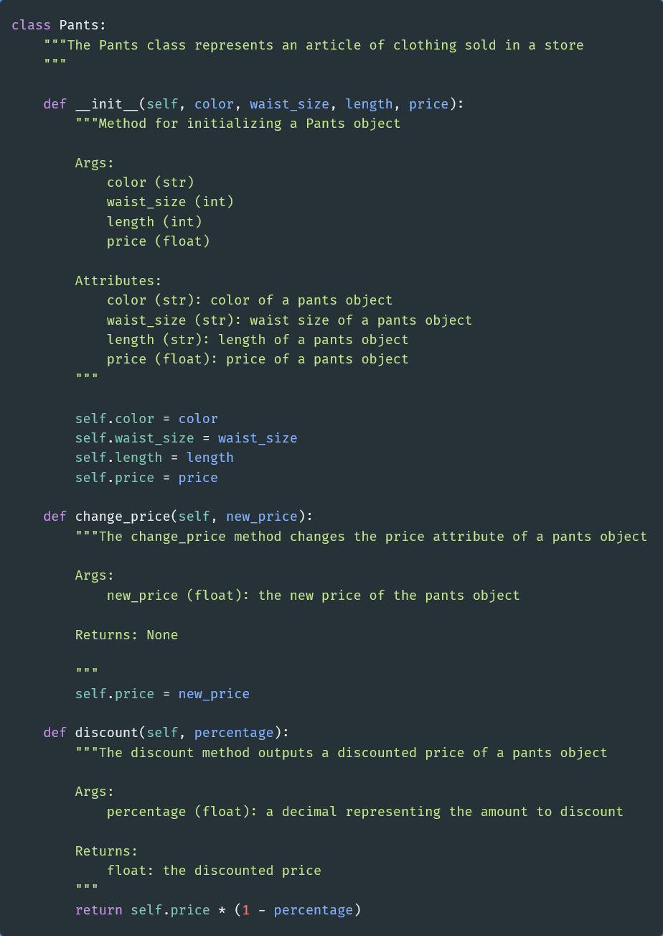

# Gaussian class

## Resources for review

The example in the next part of the lesson assumes you are familiar with Gaussian and binomial distributions.

Here are a few formulas that might be helpful:

### Gaussian distribution formulas

#### Probability density function

$$f\left(x | μ,σ^{2}\right)= \frac{1}{\sqrt{2πσ^{2}}}e-\frac{{(x-μ)}^{2}}{2σ^{2}}$$

 where: μ is the mean; σ is the standard deviation; σ2 is the variance

### Binomial distribution formulas

#### Mean

$$μ=n*p$$

In other words, a fair coin has a probability of a positive outcome (heads) p = 0.5. If you flip a coin 20 times, the mean would be 20 * 0.5 = 10; you'd expect to get 10 heads.

#### Variance

$$σ^{2}=np(1-p)$$

Continuing with the coin example, n would be the number of coin tosses and p would be the probability of getting heads.

#### Standard deviation

$σ=\sqrt{np(1-p)}$

​

In other words, the standard deviation is the square root of the variance.

#### probability density function

$$f\left(k,n,p\right)= \frac{n!}{k!\left(n-k\right)!}p^{k}{(1-p)}^{n-k}$$

# Magic Methods

# Inheritance